EVENTS
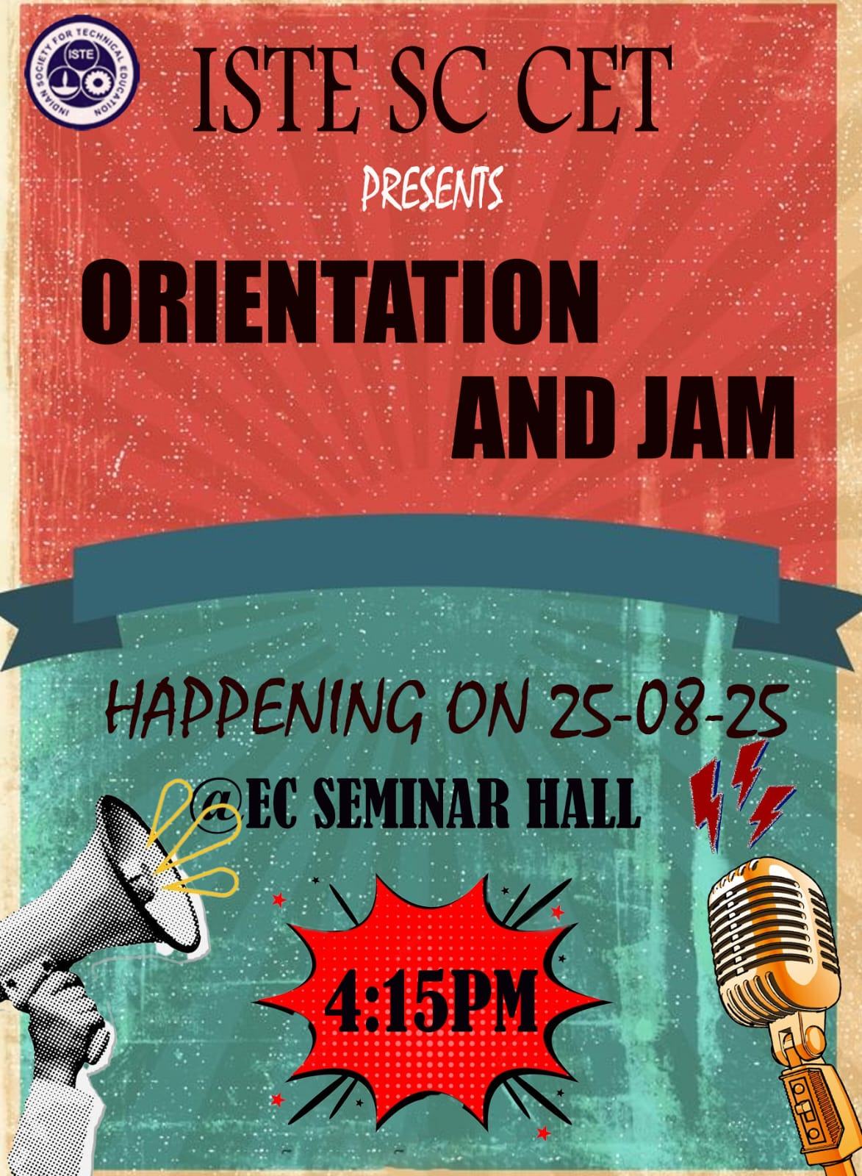 | Event Overview:  Date: 25 August 2025  Venue: EC Seminar Hall  Time: 4:15 PM  Organized by ISTE SC CET in collaboration with Cetunes.  Provided an engaging orientation session for students to learn about the ISTE community.  Featured JAM (Just A Minute) activities to encourage creativity and confident expression.  Created a platform for students to connect, collaborate, and interact with fellow members.  Encouraged active participation, communication, and idea sharing among students.  Marked the beginning of an engaging journey with ISTE SC CET.
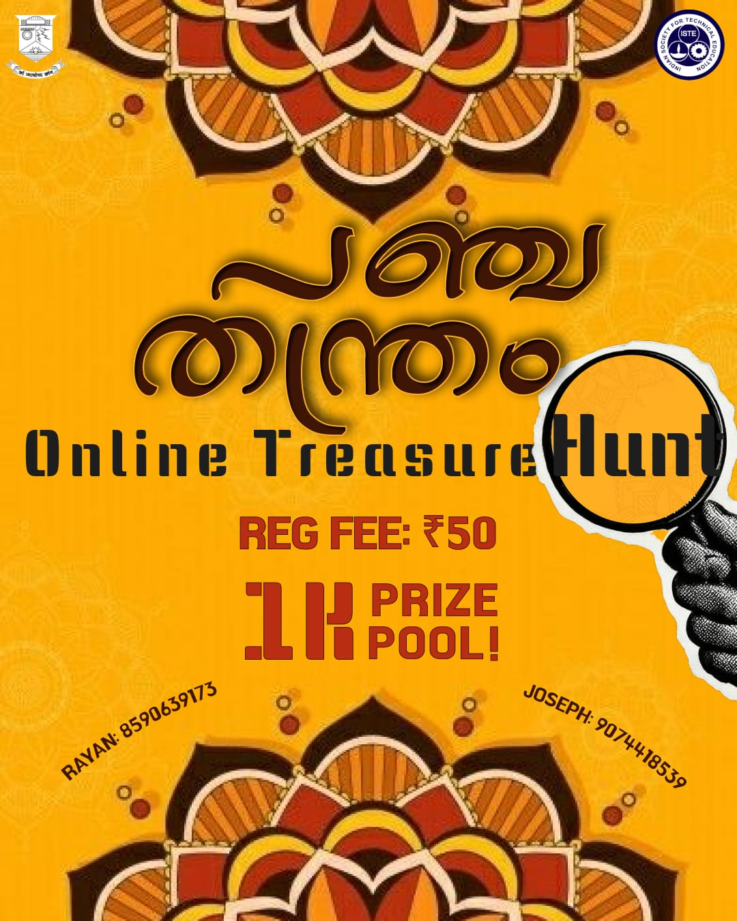 | ONLINE TREASURE HUNT – പഞ്ചതന്ത്രം  Event Overview:  Mode: Online  Date: 6 September 2025  Time: 4:00 PM  Registration Fee: ₹50  Prize Pool: ₹1000  Open to: All Years  Team Size: Individual or teams of up to 4 members  Organized by ISTE SC CET as part of the Onam celebrations.  Featured an engaging online treasure hunt involving puzzles, riddles, and challenging clues.  Encouraged participants to apply logical thinking, problem-solving, and creativity to progress through the hunt.
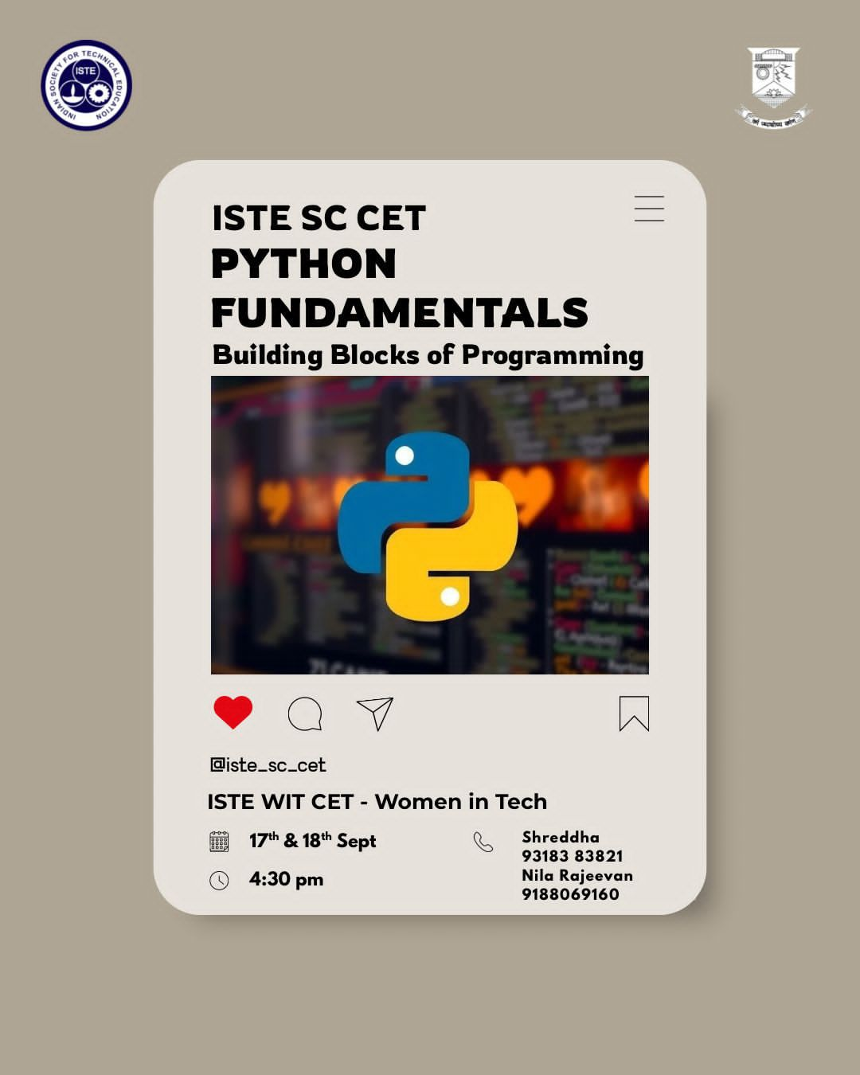 | PYTHON FUNDAMENTALS - BUILDING BLOCKS OF PROGRAMMING  Event Overview:  Date: 17 & 18 September 2025  Time: 4:30 PM  Organized by ISTE SC CET – Women in Tech.  Introduced participants to the fundamentals of Python programming and its applications in modern technology.  Provided an opportunity to explore how Python is used in web development, artificial intelligence, data science, and application development.  Designed for beginners, requiring no prior programming experience.  Encouraged participants to develop programming skills and problem-solving abilities through an engaging learning experience.  Aimed to help students build a strong foundation in Python and gain confidence in their coding journey.
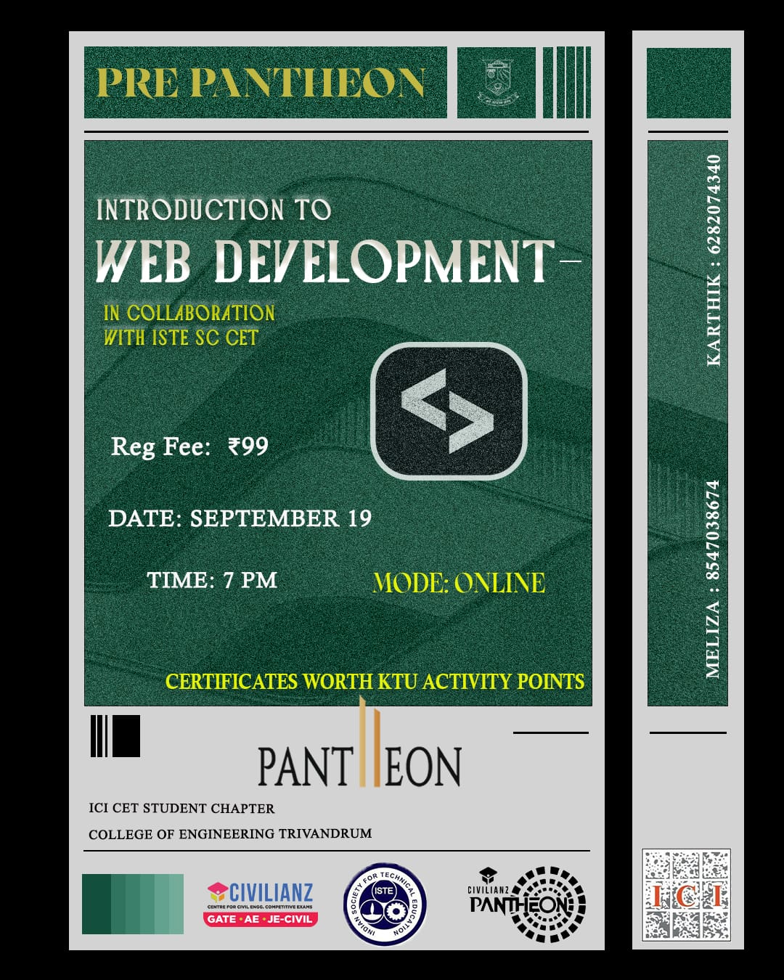 | INTRODUCTION TO WEB DEVELOPMENT  Event Overview:  Date: 19 September 2025  Time: 7:00 PM  Mode: Online  Registration Fee: ₹99  Organized by Pantheon 11 in collaboration with ISTE SC CET.  Conducted as a beginner-friendly workshop introducing participants to the fundamentals of web development.  Provided an opportunity to understand how websites are built and explore the basics of creating web pages.  Designed for students with little or no prior experience in web development.  Aimed to encourage participants to develop their technical skills and interest in web development.  Participants were eligible to receive certificates worth KTU activity points.
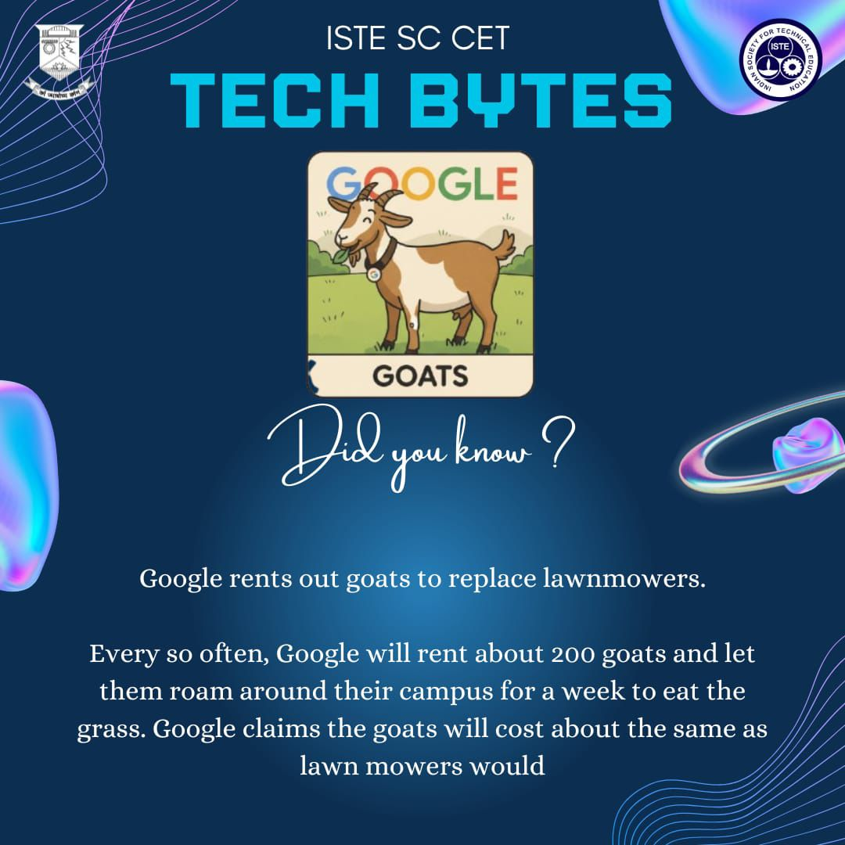 | TECH BYTES  Initiative Overview:  A technology-focused awareness initiative by ISTE SC CET aimed at sharing interesting and informative facts related to the world of technology.  Presented short, engaging tech facts through visually appealing content to make technological concepts and innovations accessible to students.  Covered a variety of topics connecting technology, innovation, sustainability, and real-world applications.  Encouraged students to explore and stay informed about interesting developments and applications of technology.  The initiative served as an engaging platform for knowledge sharing and technological awareness among the student community.
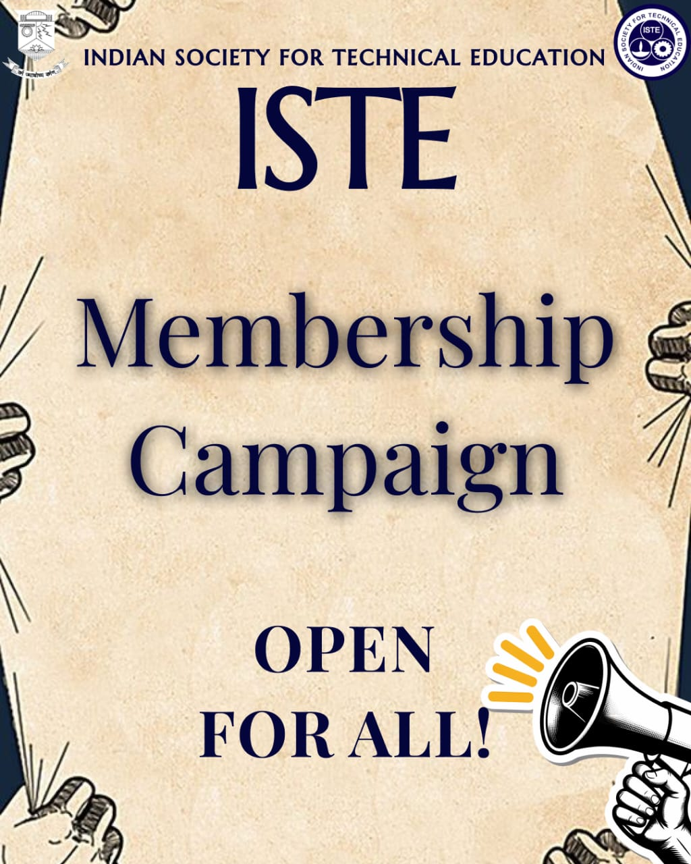 | ISTE MEMBERSHIP CAMPAIGN  Campaign Overview:  Organized by ISTE SC CET to introduce students to the ISTE community and encourage them to become active members.  Promoted a community that inspires creativity, fuels innovation, and develops leadership skills among students.  Encouraged students to connect with like-minded individuals and engage in technical and professional activities.  Aimed to provide students with opportunities to learn, collaborate, innovate, and grow through participation in ISTE.  The campaign highlighted ISTE as a platform for students to contribute to and shape the future of technology.
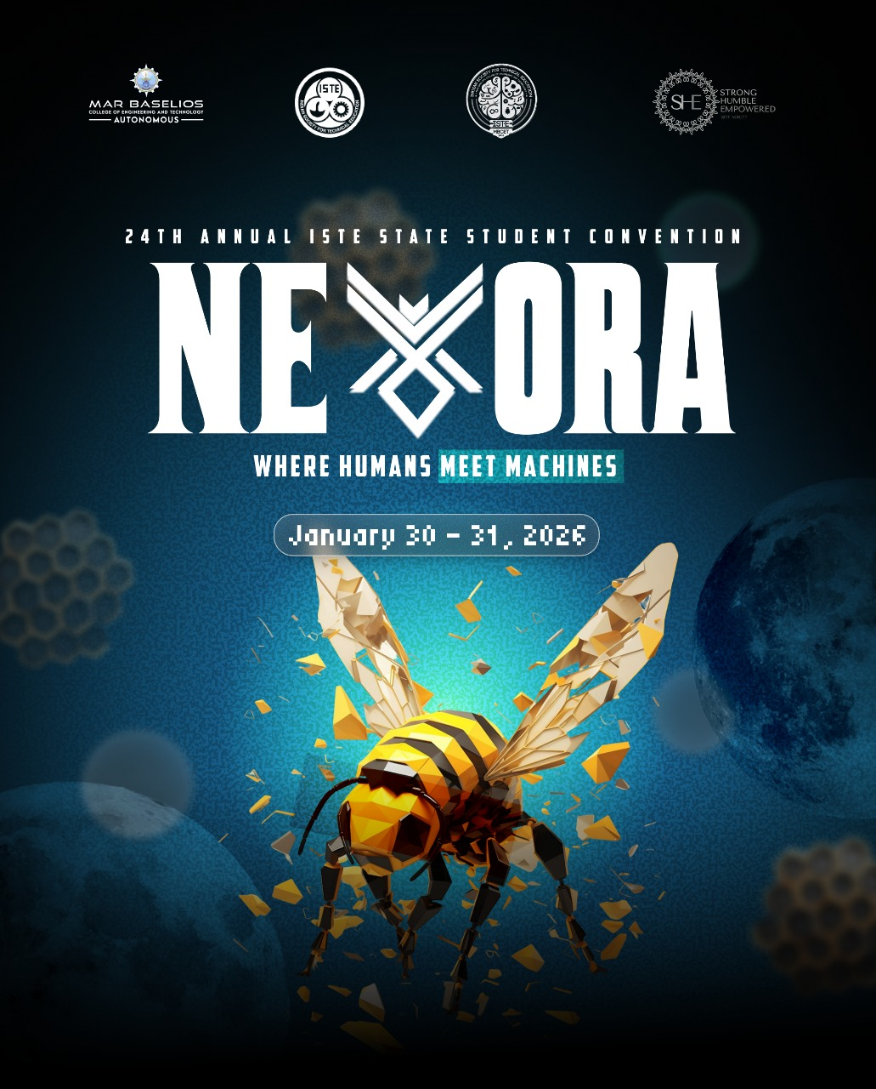 | NEXORA 2026 – 24th ISTE ANNUAL STATE STUDENT CONVENTION  Event Overview:  Date: 30 & 31 January 2026  Venue: Mar Baselios College of Engineering and Technology (Autonomous), Nalanchira, Thiruvananthapuram  Theme: Industry 5.0: Smart and Sustainable Engineering for a Better Tomorrow with AI  Hosted by Mar Baselios College of Engineering and Technology in collaboration with the ISTE Kerala Section.  Marked the 24th Annual ISTE State Student Convention, bringing together 1000+ students, innovators, researchers, entrepreneurs, and industry leaders.  Featured keynote sessions, expert panels, innovative exhibitions, and ideathons focused on emerging technologies and innovation.  Provided a platform for students to learn, network, exchange ideas, and engage with industry professionals.  Focused on Industry 5.0, artificial intelligence, smart engineering, and sustainable technological development.  Created opportunities for students to explore emerging technologies and transform innovative ideas into meaningful solutions.
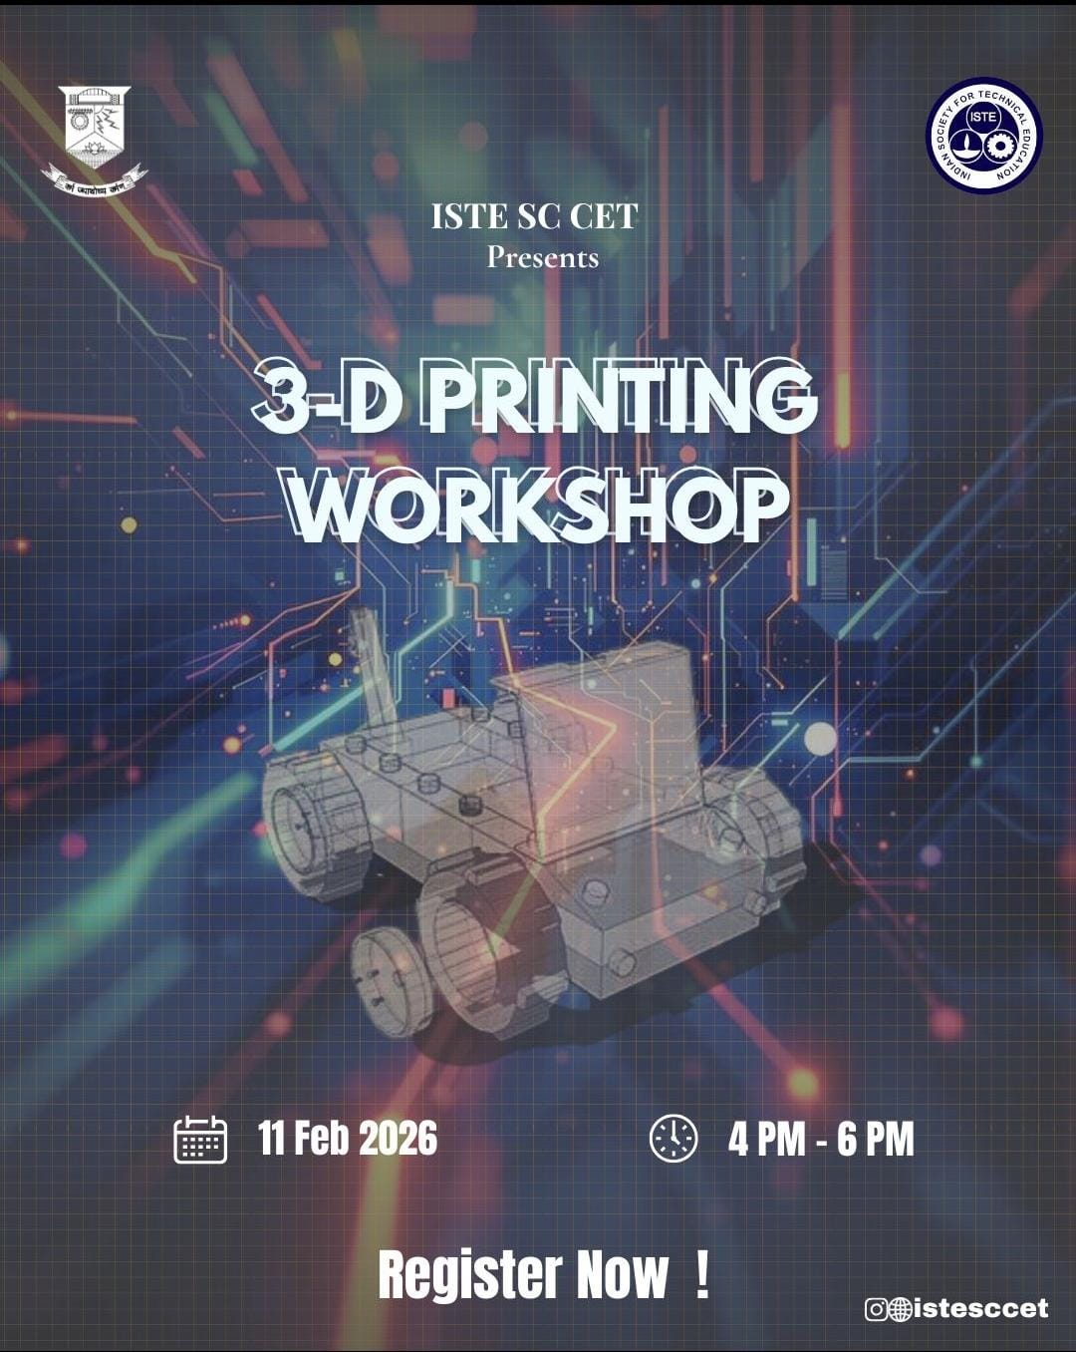 | 3-D PRINTING WORKSHOP  Event Overview:  Date: 11 February 2026  Time: 4:00 PM – 6:00 PM  Venue: 3D Printing Lab, Industrial Department  Organized by ISTE SC CET as an introductory session on 3D printing technology.  Provided participants with an opportunity to understand how digital designs are transformed into physical objects.  Featured a live demonstration showcasing the complete 3D printing process step by step.  Introduced participants to the working principles and practical applications of 3D printing.  Created an engaging learn-by-observation experience, helping students gain a better understanding of the technology through direct demonstration.
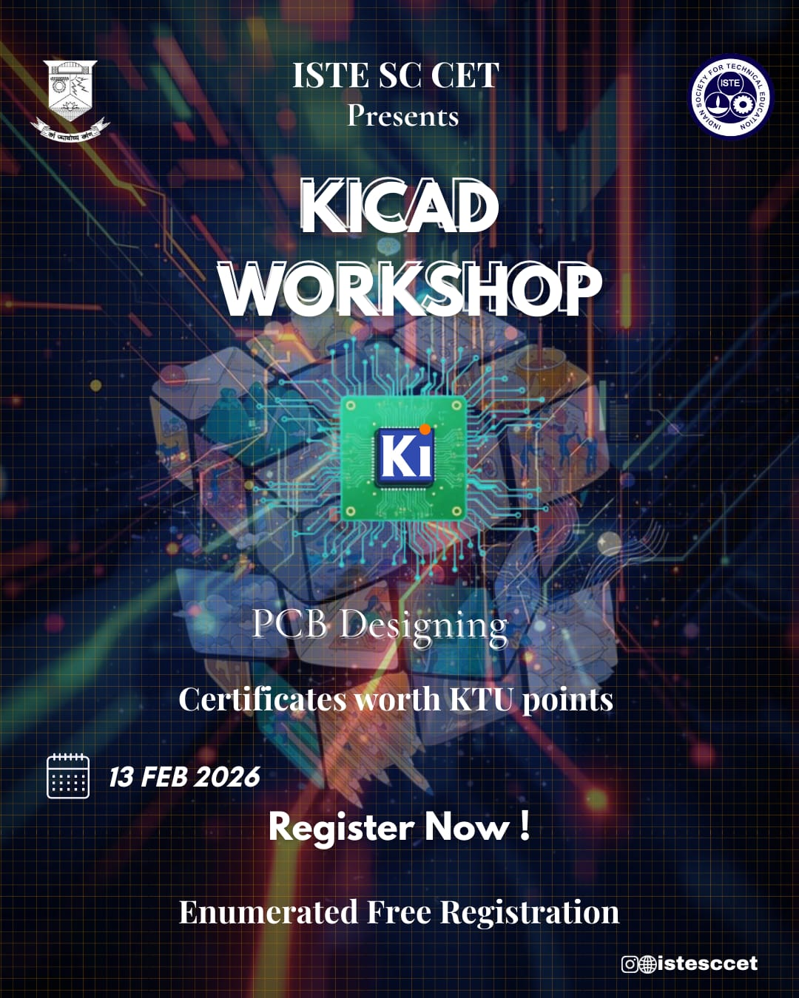 | KICAD WORKSHOP – PCB DESIGNING  Event Overview:  Date: 13 February 2026  Time: 7:00 PM  Mode: Online  Organized by ISTE SC CET as an introductory workshop on PCB designing using KiCad.  Introduced participants to the process of designing printed circuit boards from scratch using industry-relevant tools.  Provided step-by-step guidance on schematic creation and PCB layout in a simple and practical manner.  Enabled participants to understand how electronic circuits are transformed into functional PCBs.  Encouraged students to develop their design and technical skills through hands-on learning.  Participants received certificates worth KTU activity points.
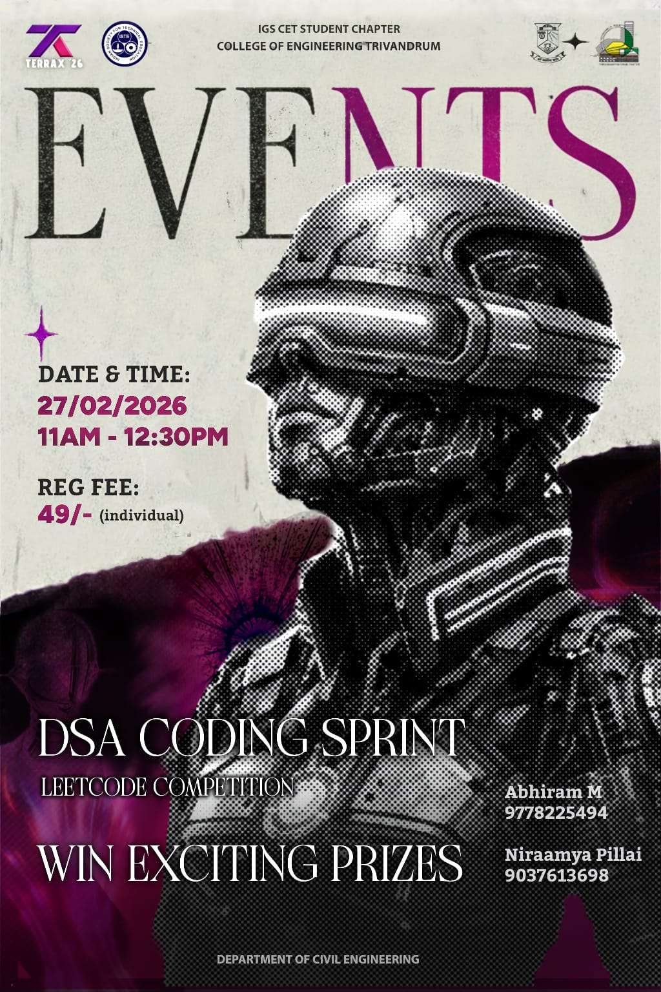 | DSA CODING SPRINT – LEETCODE COMPETITION  Event Overview:  Date: 27 February 2026  Time: 11:00 AM – 12:30 PM  Mode: Offline  Registration Fee: ₹49 (Individual)  Organized as part of Terrax’26 by the IGS CET Student Chapter.  Conducted as a LeetCode coding competition focused on Data Structures and Algorithms (DSA).  Provided participants with an opportunity to apply their problem-solving and coding skills in a competitive environment.  Designed for students interested in competitive programming and building careers in software and technology.  Encouraged participants to strengthen their algorithmic thinking, coding efficiency, and logical reasoning.  The competition featured exciting prizes, motivating participants to challenge their programming abilities.

